**PRATIMA BHATTARAI**

**Lab 1**

1. The internet address of my computer is 10.8.48.138
2. The three different protocols that appear in the protocol coloumn in the unfiltered packet listing window in step 7 above are;

* TCP
* DNS
* UDP

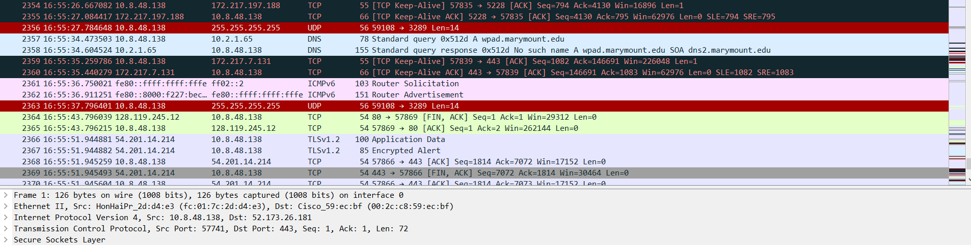

3.The duration of time it took is explained below.

Get time= 16:54:51:525858

OK time = 16:54:51:572943

So, Duration= 16:54:51:572943-16:54:51:525858=0.47085 seconds.

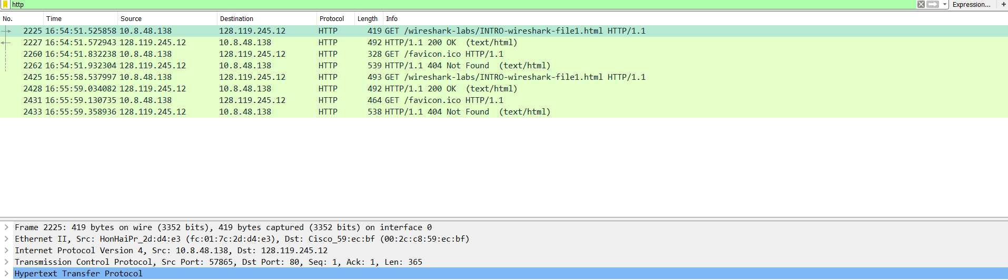

1. The internet address of the gaia.csumass.edu is 128.119.245.12